Positioning Tesla's Phone Tags on iPhones and other SMART phones
Positioning Computer Tag Sets on Laptops and back of iPads and Tablets
The Phone Tags are positioned on the back of the phones, under the cover if possible, however if this is not possible, place the phone tags on the outside of the cover and it will work equally as well. The usual position on SMART phones is as below for IPhone 3. The IPhones 4, 5 and 6, are different due to the aerial being positioned round the edge of the phone, so it is recommended to place the Phone Tag as close to the edge of the phone as possible in the positions shown. And always position phone tags with a straight edge parallel with the top and bottom of the phone.
Computer Tag Sets are NOT designed for Mobile Phones they are strictly for Laptops, iPads and Tablets only.
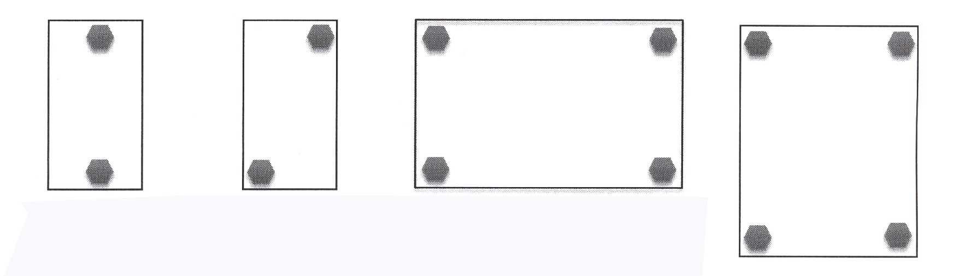
iPhone 3
& other
SMART phones

IPhone 4, 5 & 6

Position Computer Tag Set on back of Laptops this way

Position Computer Tags on back of iPad and Tablets like this

